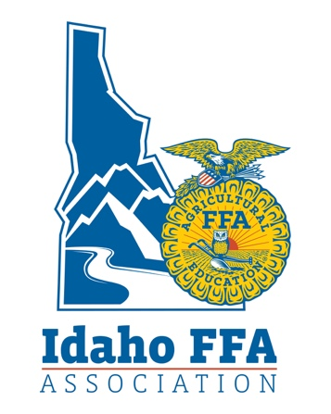

DISTINGUISHED SERVICE AWARD
APPLICATION

Purpose:
The Distinguished / Honorary Service Award is reserved for companies or individuals who have rendered outstanding statewide support over a period of time to AFNR Education and the FFA. It is generally given to those outside of the active AFNR Education profession.
Selection Procedure
1. Nomination forms must be submitted by your District Director via email by the end of the current calendar year so the Director has time to submit these to the Idaho FFA Association prior to the Midwinter Idaho FFA Board Meeting. INCOMPLETE APPLICATIONS WILL NOT BE REVIEWED. APPLICATIONS ARE INCOMPLETE WITHOUT A BIO. NO EXCEPTIONS.
3. Final selection will be made by the Idaho FFA Association Board of Directors.
4. Distinguished Service Awards shall be presented at that year's State FFA Convention or at an alternate time and location if recipient cannot attend the State FFA Convention.

Person Making Nomination:
Contact Info: | Phone: |  |  | E-Mail:
Name of Nominee: |  |  |  | Occupation:
Mailing Address:
City, State, Zip Code
Contact Info: | Phone: |  |  |  | E-Mail:
Contributions at State Level  Biographical Information:  Affiliations & Recognitions: |  |  | Please type script to be read on stage: 200 words or less (see and pattern this from the sample bios next page)
Signature of approval by local FFA Advisor__________________________
Approved by Idaho FFA Board of Directors Yes No Date: __________________
Signature of State FFA President: _____________________________________
Sample Bios
Baker Auction Company:
The Baker Auction company is a proud supporter of agricultural youth development, especially the FFA. The Baker Auction Company has been helping FFA students in the Western Idaho and Boise Valley Districts achieve the highest possible market prices for their fair hogs, steers, lambs, and goats for over 35 years. Auctioneers Roger, Sam and J.B. work their voices and have used their personal contacts and relationships that they have developed within the livestock industry to help persuade buyers to reach higher and higher prices for each FFA member selling a market animal. The spirit in which they market each member is second to none. Despite how much money buyers are persuaded to lay down, everyone is left with a feeling of warmth and good cheer. Idaho FFA members are lucky to have the Baker Auction Company as friends and supporters. We are proud to present the Baker Auction Company with the 2011 Idaho FFA Association Distinguished Service Award.

Scarrow Meats:
Scarrow Meats’ contribution to Agricultural Education and the FFA are extensive and wide-spread across state lines. Over the last 15 years they have supported local FFA chapters by donating the cutting and wrapping of animals for silent auctions. Scarrow Meats also provides meat for FFA events at low costs as well as the use of a large Bar-B-Que. Their support extends into the classroom by providing items for classroom dissections and activities, as well as opening their doors for FFA members to practice for the state level Meats Evaluation CDE. Scarrow Meats donates meat for the Annual Buyers Breakfast at the Jerome County Fair, sponsors the County Tri-Tip Cook-Off, and donates equipment for FFA and community events. Their contributions continue by providing the facility and product for the South Magic Valley District Meats Evaluation CDE every year as well as establishing floor prices for 4-H and FFA junior market animal sales in 7 Idaho counties and 1 Nevada county. Scarrow meats processes animals from 12 Idaho and Nevada youth livestock sales and purchases animals at 11 Idaho Junior Market animal sales. There is no doubt that Scarrow Meats is extremely passionate about FFA and agricultural development. We are pleased to present them with the 2011 Idaho FFA Association Distinguished Service Award.

Revised 10/2021

