Idaho FFA Board of Directors- Summer Meeting
MINUTES
23 June 2022
8:00 AM MDT
Start Time: 8:10 AM MST
University of Idaho:
Dr. Kattlyn Wolf
Idaho FFA Foundation:
Marcia Jedry, Executive
Director
Legislative Liaison (non-
member):
Shawn Dygert
Idaho FFA Alumni:
Lance Zollinger
Co-chairs:
Halee Bohman & Cody
Park
FFA Executive
Director:
Clara-Leigh Evans

State FFA Officers:
Halee Bohman- President
Elizabeth Shaw- Vice President
KaLisi Giggs- Secretary
Mackenzie Malsom- Treasurer
Ember Mendoza- Reporter
Korby Lindsey- Sentinel
Kayden Driggs- Past State Officer
IATA Officers:
Sam Hoffman- President
Shane Wetzel- President-Elect
Cody Porath- Past President
IATA District Directors:
Josette Nebeker- North Idaho
Brandee Lewis- North Magic Valley
Mike Tesnohlidek- Western Idaho
Dan Billington- South Magic Valley
VACANT- North Upper Snake
Andy Nelson- East Magic Valley
Janna Volkers- Boise Valley
Cody Park- South Upper Snake
River
Larin Crossley- Southeastern Idaho
Jason Tindall- Treasure Valley
State Program Manager:
Lucas Barnett

Link to 2021-2022 Idaho FFA Board of Directors Google Folder

Opening Ceremonies
Introductions
Approval of Spring Meeting Minutes
- Unanimously accepted the Spring Meeting Minutes
Old Business:
Budget- Clara-Leigh
- Clara-Leigh moved to move $30,000 from the checking account into a savings account
- Motion passed
- Dr. Wolf moved to approve the budget as presented.
- Motion passed
New Business:
State FFA Advisor Report- Lucas Barnett
State Officer Report
Idaho FFA Foundation Report- Clara-Leigh Evans shared for Marica Jedry
Idaho FFA Alumni & Supporters Report- None
IATA Report- Sam Hoffman
- 160 ag teachers were present
- All committees meet and completed reports- see IATA reports and action items below in this document.
Delegates to the 91st Idaho FFA State Convention recommended decreasing the per member amount from Idaho FFA state dues going to the Idaho FFA Foundation from $2 to $1 beginning FY23.
- Dr. Wolf moved to approve the delegates recommendation
- Motion Passed
Increase Idaho FFA credit card limit
- Clara-Leigh moved to increase the credit card limit at DL Evans Bank to $20,000 to be split among state staff: FFA Executive Director Clara-Leigh Evans, CTSO Manager Jessie Kellogg, and State FFA Advisor, Lucas Barnett
- Motion Passed
Schedule Fall 2022 Meeting
- Sam Hoffman moved to schedule the Fall meeting on Oct 6 at 430 pm mt
- Motion Passed

Adjourn 10:04 AM

Idaho FFA Foundation Update
Summer Idaho FFA Board of Directors 2022

Scholarship Raffle raised $130,200 with $65,100 going directly back to chapters total scholarships will be announced after all expenses have been entered will be no less than $22,000 plus one additional Ag Ed scholarship

SAE grants will receive a one-time donation of $100,000 to be used over the next 5 years with $20,000 in SAE grants at $500 each
In addition to the Peterson EMERGE grants for the FFA Chapters – New EMERGE Grants
- Two $5,500 grants to be awarded to separate FFA Chapters with focus on
vegetable/horticulture/greenhouse production
- 5 additional SAE Grants for vegetable/horticulture/greenhouse focus

Goal is set to reach 100 Gift of Blue jackets I the 2022-2023 membership year

Scholarship applications significantly simplified for students to apply – please encourage kids to apply – the goal is to have as many applicants as possible across the state to award scholarships to students, applications available in September.

Golf Tournaments between Boise and Buhl we raised over $72K and after expenses netted about $40,000, expenses still coming in and proceeds will be used for 2022-2023 programs, Idaho Falls and Lewiston tournaments still to come
Funded additional programmatic expenses through the Idaho FFA Association of about $45,215 this year

IATA Committees
FFA Action Items
Summer Conference 2022

- FFA Relations
- Gem State Leadership Conference
- FFA Relations Committee recommends that the Gem
State Leadership Conference has clear and concise expectations of dress
on the registration form reinforced by teachers.
- SLC/State Convention
- FFA Relations Committee recommends that when
registration for state convention opens delegate issues will be made
available to all chapters.
- FFA Board of Directors
- FFA Relations Committee recommends that no action be
taken on limiting State Officers to one vote on the FFA Board of Directors.
- FFA Award and State Convention Sessions
- FFA Relations Committee recommends that we take no
action on the item to limit time of FFA Awards and State Convention
sessions.
- FFA Board
- FFA Relations Committee recommends that Clara-Leigh works with the FFA Board of Directors to update standing rules on creating a procedure for FFA business to flow through IATA committees, student delegates, and FFA Board of Directors.
- Virtual CTE School
- FFA Relations Committee Recommends that the virtual
FFA Chapter for ITCA’s K-12 begins the process for an FFA Charter and
the chapter be placed in a district. Students need to be enrolled in an
accredited virtual school full-time, that receives state CTE funding and
cannot be dual enrolled in another K-12 school.
- CDE
  - General Rules
    - IATA recommends that we eliminate 2020 as a possible exam
    - IATA recommends that the board passes a motion to add to the general rules that smartwatches not be allowed during contests. Change would make the section now read “All electronic devices, phones, smartwatches, etc…”
    - IATA recommends that the board pass the motion that Idaho CDE’s be open to continuous changes as recommended by the Idaho FFA delegates, the IATA, with a final vote by the FFA Board of Directors if posted by October 1st.
    - IATA recommends that the board pass the motion that new official state CDE’s must be approved by the Idaho FFA delegates, the IATA, and the Idaho FFA Board of Directors by summer conference the year before they are officially offered.
    - IATA recommends the board pass the motion that all rules have their firm revision date removed from the cover page with the addition of a revised date when each CDE is updated on the title page and header.
      - EX: 2017-2022 would now read “Revised 6/20/22”
  - Food Science
    - IATA recommends that we fix the food science rules to match the scorecards used to grade the contest.
      - Food science rules have discrepancies. The aromas were worth 50 points at state, the rules say 25 points (page 4) but the scorecard in the rules says 50 (page 10). The triangle tests were worth 45 points at state, the rules say 30 points (page 4) but the scorecard in the rules says 45 (page 10).
  - Dairy Handlers Activity
    - IATA recommends that the board pass the motion that advisors who have members in the dairy handlers don’t judge the event
  - Potato Evaluation
    - IATA recommends that the board pass the motion to approve the Potato CDE as an official CDE event.
    - IATA recommends that the board pass the motion to have 2 more placing classes in addition to the previous proposed rules.
    - IATA recommends that the board pass the motion that we add into the Potato CDE rules that students may not bring any pre-printed or hand written materials to the event.
  - Horse Evaluation
    - IATA recommends that the board pass the motion to add to the official state rules in the general section that all halter class horses will be judged as sound.
  - Agronomy
    - IATA recommends that the board pass the motion that the agronomy fertilizer scorecard total field cost is 10 points each from the current listed 5 points.
    - IATA recommends that the board pass the motion to remove “weeds of any stage” from the rules.
    - IATA recommends that the board pass the motion that the rules list that scab and wilt will not be on grain seed heads for samples.
    - IATA recommends that the board pass the motion to provide a list of prohibited and restricted weeds prior to the CDE, included with CDE resources email
    - IATA recommends that necrosis be removed from the CDE list in agronomy.
  - Livestock Judging
    - IATA recommends the board pass the motion that all contestants will give reasons at the end of the livestock judging contest rather than in the rotation.
  - Nursery Landscape
    - IATA recommends the board pass the motion that the nursery stock practicums states that 5 cuttings will be taken.
    - IATA recommends the board pass the motion to remove white fir, spreading cotoneaster, and white ash from the state ID list.
    - IATA recommends the board pass the motion to add butterfly bush; coral bells, alumroot; black-eyed susan; english lavender; eastern white pine; sweet gum; clematis; tuliptree; bigleaf hydrangea; and rhododendron to the ID list.
    - IATA recommends the board pass the motion to update the equipment/supplies list so that it follows the national list.
    - IATA recommends the board pass the motion to update the disorders list to include the 5 beneficial insects.
  - ENR
    - IATA recommends the board pass the motion to accept the changes to the ID practicum listed below.
      - Remove: binoculars
      - Add:
      - • TOOLS: Turbidity tube (for stream turbidity)
      - • WILDLIFE: river otter, pine martin
      - • BIRDS: Crow, raven, pintail duck, magpie
      - • FISH: Mountain Whitefish, Yellow Perch, Kokanee Salmon
      - • PLANTS: Big Sagebrush, Arrowleaf Balsamroot, Bluebunch Wheatgrass, Coyote Willow, Nebraska Sedge, Smooth Brome, Downy Brome (aka cheatgrass), Rabbitbrush (either rubber or green rabbit rush), Antelope Bitterbrush, Baltic Rush.
      - • INVASIVE: Asiatic clams
    - IATA recommends the board pass the motion to approve the water analysis changes below and that a score card is adopted that can be sent out and approved prior to October 1st.
      - Water Analysis. (Dr. Frank Wilhelm, UI Limnologist, suggested the water analysis revisions to reflect current practices in the field. Dr. Wilhelm will develop guidelines for testing and provide turbidity parameters, range, and expected standards.)
      - The four following categories will be tested each year: pH, Dissolved Oxygen, and Turbidity, and Temperature.
      - • Turbidity is being substituted for Nitrates in current version of this practicum.
      - • Test results for each of these 4 water quality attributes will be worth 10 points each.
      - Question “Effect on Environment” changed to “Effects on Specific Setting outlined at site”
      - • Three questions on score card (Effect on Specific Setting, Limiting Factors, and How can Water Quality be Improved?) will be worth 20 points each. (No change to point value.
      - Tools and Resources Needed (will be provided at event):
      - Hach pH meter, Dissolved Oxygen Meter, Carolina Turbidity Tube (Field Master), and Thermometer.
  - CCM
    - IATA recommends the board pass the motion that Conduct of Chapter Meetings LDE include a semi-final and final round at the state event.
  - CCM & Parli
    - IATA recommends the board pass the motion that CCM and Parli be broken into two flights for the semi-final round at state and that teams will be placed in flights based on their test scores. Flight #1 includes 1-4-5-8-9 and Flight #2 includes 2-3-6-7-10. Top 2 teams from each flight will advance to the finals and their test scores follow them through the event.
  - Milk Quality and Products
    - IATA recommends the board pass the motion that rice and almond be added with soy in the dairy/non-dairy section.
    - IATA recommends the board pass the motion that dairy vs. non- dairy be replaced with natural vs. imitation.
  - Vet Science
    - IATA recommends that the board pass the motion to eliminate the current event practicum from the vet science CDE.
  - Miscellaneous
    - IATA recommends that the board approve the Ag Ed CDE as an invitational for the coming year with rules as posted by Clara-Leigh

- SAE
  - State Star and Proficiency Awards
    - IATA recommends the board pass the motion to set the tiebreaker for State Stars and Proficiency awards as the interview score as determined by the interview committee at the Idaho FFA State Convention.
    - IATA recommends that the board pass the motion to approve the amended checklist.
      - Please refer to the checklist handout- see supplement in this document
    - IATA recommends the board pass the motion to have districts’ State Degrees forwarded to the State Advisor by first Monday in February, revisions by State Degree Evaluation Committee begin within 2 days, and evaluation of degrees are to be completed within 10 days. Revised applications will be submitted to the State Advisor prior to the fourth Monday in February and a list of recipients completed and shared with FFA State Staff by March 1st.
- Legislative Action
  - License Plate
    - IATA recommends that we create an Idaho FFA license Plate.
- Curriculum Committee
  - Middle School Curriculum
    - IATA moves to send the middle school standards to the board for their approval.

Proposed State Degree Checklist from IATA

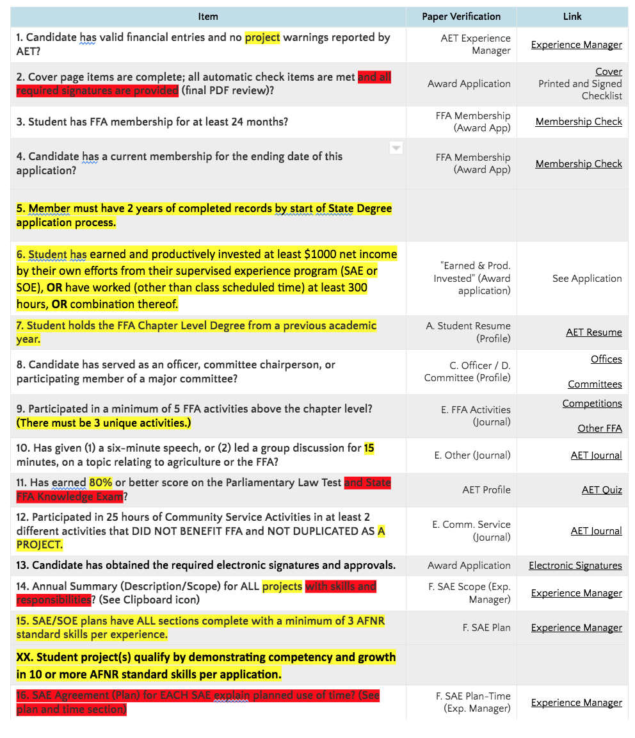

CONTINUED...
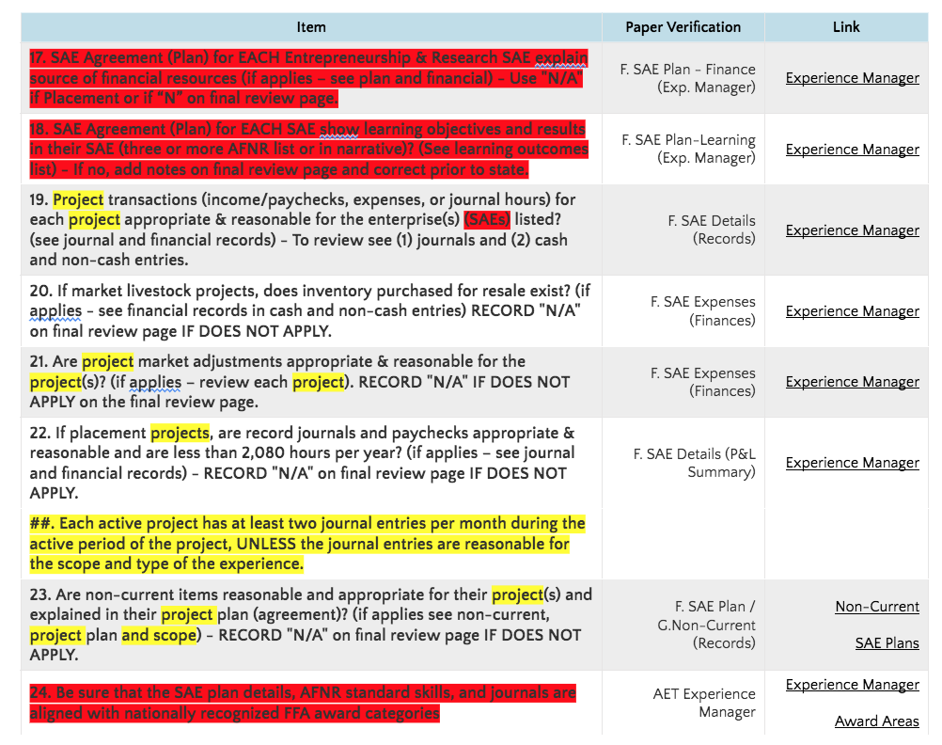

END

