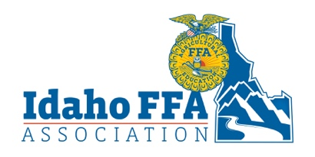
2022 Idaho FFA
Delegate Proposal Form
The FFA Mission - FFA makes a positive difference in the lives of students by developing their potential for premier leadership, personal growth, and career success through agricultural education.

Chapter:
Issue:
Summary: Using only the space provided below, please summarize your issue into no more than five
main points.
1.
2.
3.
4.
5.
Support: Using only the space provided below, please explain the supporting evidence for your main
points.
Wording: Use the space below to precisely phrase your issue in the form of a motion.

